**­DIGITAL SIGNAL PROCESSING LAB EXPT.2**

**CONVOLUTION, CROSS AND AUTO CORRELATION OF DISCRETE SIGNALS**

**GHOSH SUHIRD**

**22BEC1119**

**AIM: To perform the following operations:**

**➢ Convolution (with and without using built-in command)**

**➢ Cross-Correlation**

**➢ Auto-Correlation**

**on discrete signals**

1. **CONVOLUTION WITHOUT USING BUILT-IN COMMAND**

clc;

clear all;

close all;

x = input("Enter the input sequence x[n]: ");

h = input("Enter the input sequence h[n]: ");

xlen = length(x);

hlen = length(h);

ylen = xlen + hlen -1;

for i = 1:xlen

for j = 1:hlen

y(i,i+j-1) = x(i).*h(j);

end

end

y = sum(y);

subplot(3, 1, 1);

stem((0:xlen-1),x,'linewidth',2);

set(gca,'fontsize',13,'fontweight','bold');

xlabel('Number of Samples, n','fontsize',12,'fontweight','bold');

ylabel('Amplitude, \delta[n]','fontsize', 12,'fontweight', 'bold');

title('Input x[n]', 'fontsize', 14);

grid on;

hold on;

subplot(3, 1, 2);

stem((0:hlen-1),h,'linewidth',2);

set(gca,'fontsize',13,'fontweight','bold');

xlabel('Number of Samples, n','fontsize',12,'fontweight','bold');

ylabel('Amplitude, \delta[n]','fontsize', 12,'fontweight', 'bold');

title('Input h[n]', 'fontsize', 14);

grid on;

hold on;

subplot(3, 1, 3);

stem((0:ylen-1),y,'linewidth',2);

set(gca,'fontsize',13,'fontweight','bold');

xlabel('Number of Samples, n','fontsize',12,'fontweight','bold');

ylabel('Amplitude, \delta[n]','fontsize', 12,'fontweight', 'bold');

title('Output y[n]', 'fontsize', 14);

grid on;

hold on;

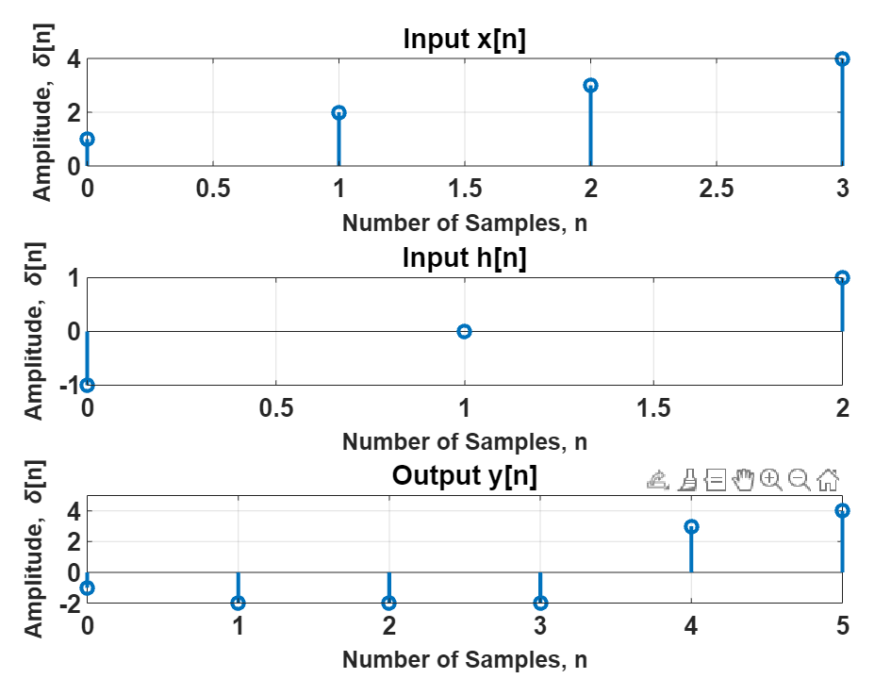

1. **CONVOLUTION USING BUILT-IN COMMAND**

clc;

clear all;

close all;

x = input("Enter the input sequence x[n]: ");

h = input("Enter the input sequence h[n]: ");

xlen = length(x);

hlen = length(h);

ylen = xlen + hlen -1;

y = conv(x, h);

subplot(3, 1, 1);

stem((0:xlen-1),x,'linewidth',2);

set(gca,'fontsize',13,'fontweight','bold');

xlabel('Number of Samples, n','fontsize',12,'fontweight','bold');

ylabel('Amplitude, \delta[n]','fontsize', 12,'fontweight', 'bold');

title('Input x[n]', 'fontsize', 14);

grid on;

hold on;

subplot(3, 1, 2);

stem((0:hlen-1),h,'linewidth',2);

set(gca,'fontsize',13,'fontweight','bold');

xlabel('Number of Samples, n','fontsize',12,'fontweight','bold');

ylabel('Amplitude, \delta[n]','fontsize', 12,'fontweight', 'bold');

title('Input h[n]', 'fontsize', 14);

grid on;

hold on;

subplot(3, 1, 3);

stem((0:ylen-1),y,'linewidth',2);

set(gca,'fontsize',13,'fontweight','bold');

xlabel('Number of Samples, n','fontsize',12,'fontweight','bold');

ylabel('Amplitude, \delta[n]','fontsize', 12,'fontweight', 'bold');

title('Output y[n]', 'fontsize', 14);

grid on;

hold on;

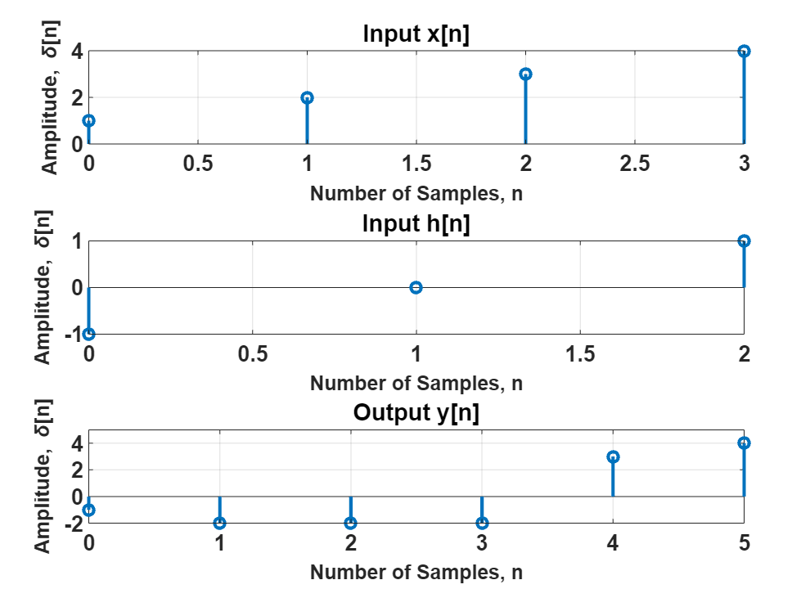

1. **CROSS-CORRELATION**

clc;

clear all;

close all;

x = input("Enter the input sequence x[n]: ");

h = input("Enter the input sequence h[n]: ");

hrev = fliplr(h);

xlen = length(x);

hlen = length(h);

ylen = xlen + hlen -1;

for i = 1:xlen

for j = 1:hlen

y(i,i+j-1) = x(i).*hrev(j);

end

end

y = sum(y);

%y = conv(x, h);

subplot(4, 1, 1);

stem((0:xlen-1),x,'linewidth',2);

set(gca,'fontsize',13,'fontweight','bold');

xlabel('Number of Samples, n','fontsize',9,'fontweight','bold');

ylabel('Amplitude, \delta[n]','fontsize', 9,'fontweight', 'bold');

title('Input x[n]', 'fontsize', 14);

grid on;

hold on;

subplot(4,1,2);

stem((0:hlen-1),h,'linewidth',2);

set(gca,'fontsize',13,'fontweight','bold');

xlabel('Number of Samples, n','fontsize',9,'fontweight','bold');

ylabel('Amplitude, \delta[n]','fontsize', 9,'fontweight', 'bold');

title('Input h[n]', 'fontsize', 14);

grid on;

hold on;

subplot(4, 1, 3);

stem((0:hlen-1),hrev,'linewidth',2);

set(gca,'fontsize',13,'fontweight','bold');

xlabel('Number of Samples, n','fontsize',9,'fontweight','bold');

ylabel('Amplitude, \delta[n]','fontsize', 9,'fontweight', 'bold');

title('Reversed h[n]', 'fontsize', 14);

grid on;

hold on;

subplot(4, 1, 4);

stem((0:ylen-1),y,'linewidth',2);

set(gca,'fontsize',13,'fontweight','bold');

xlabel('Number of Samples, n','fontsize',9,'fontweight','bold');

ylabel('Amplitude, \delta[n]','fontsize', 9,'fontweight', 'bold');

title('Output y[n]', 'fontsize', 14);

grid on;

hold on;

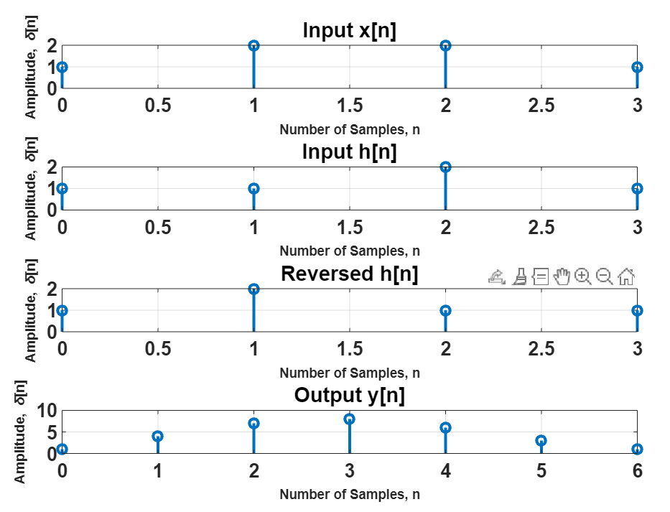

1. **AUTO-CORRELATION**

clc;

clear all;

close all;

x = input("Enter the input sequence x[n]: ");

xrev = fliplr(x);

xlen = length(x);

ylen = xlen + xlen -1;

for i = 1:xlen

for j = 1:xlen

y(i,i+j-1) = x(i).*xrev(j);

end

end

y = sum(y);

%y = conv(x, h);

subplot(3, 1, 1);

stem((0:xlen-1),x,'linewidth',2);

set(gca,'fontsize',13,'fontweight','bold');

xlabel('Number of Samples, n','fontsize',12,'fontweight','bold');

ylabel('Amplitude, \delta[n]','fontsize', 12,'fontweight', 'bold');

title('Input x[n]', 'fontsize', 14);

grid on;

hold on;

subplot(3,1,2);

stem((0:xlen-1),xrev,'linewidth',2);

set(gca,'fontsize',13,'fontweight','bold');

xlabel('Number of Samples, n','fontsize',12,'fontweight','bold');

ylabel('Amplitude, \delta[n]','fontsize', 12,'fontweight', 'bold');

title('Reversed x[n]', 'fontsize', 14);

grid on;

hold on;

subplot(3, 1, 3);

stem((0:ylen-1),y,'linewidth',2);

set(gca,'fontsize',13,'fontweight','bold');

xlabel('Number of Samples, n','fontsize',12,'fontweight','bold');

ylabel('Amplitude, \delta[n]','fontsize', 12,'fontweight', 'bold');

title('Output y[n]', 'fontsize', 14);

grid on;

hold on;

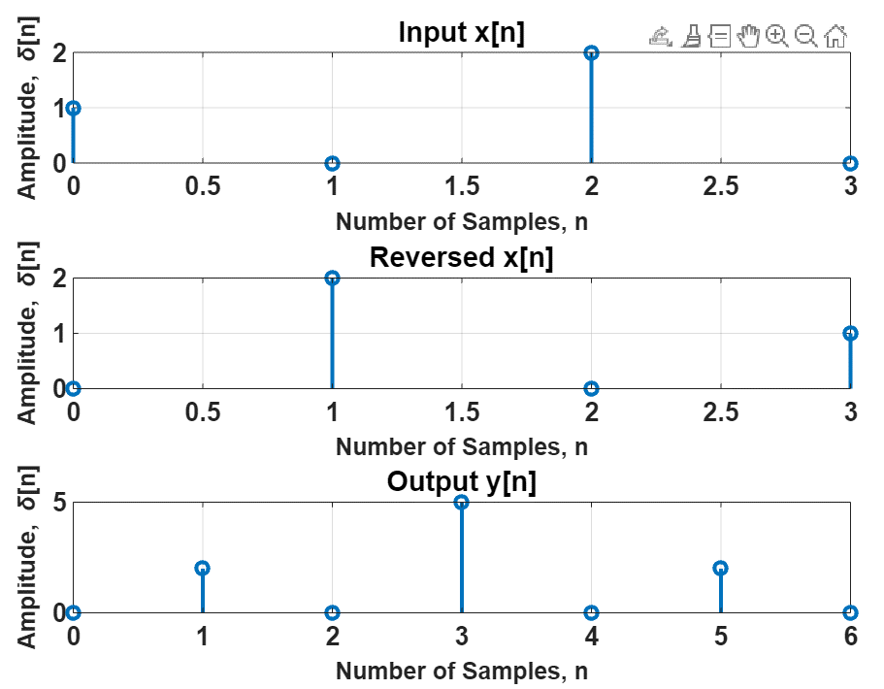**INPUT: [1 0 2 0]**

**OUTPUT VERIFICATION**

1. **CONVOLUTION**

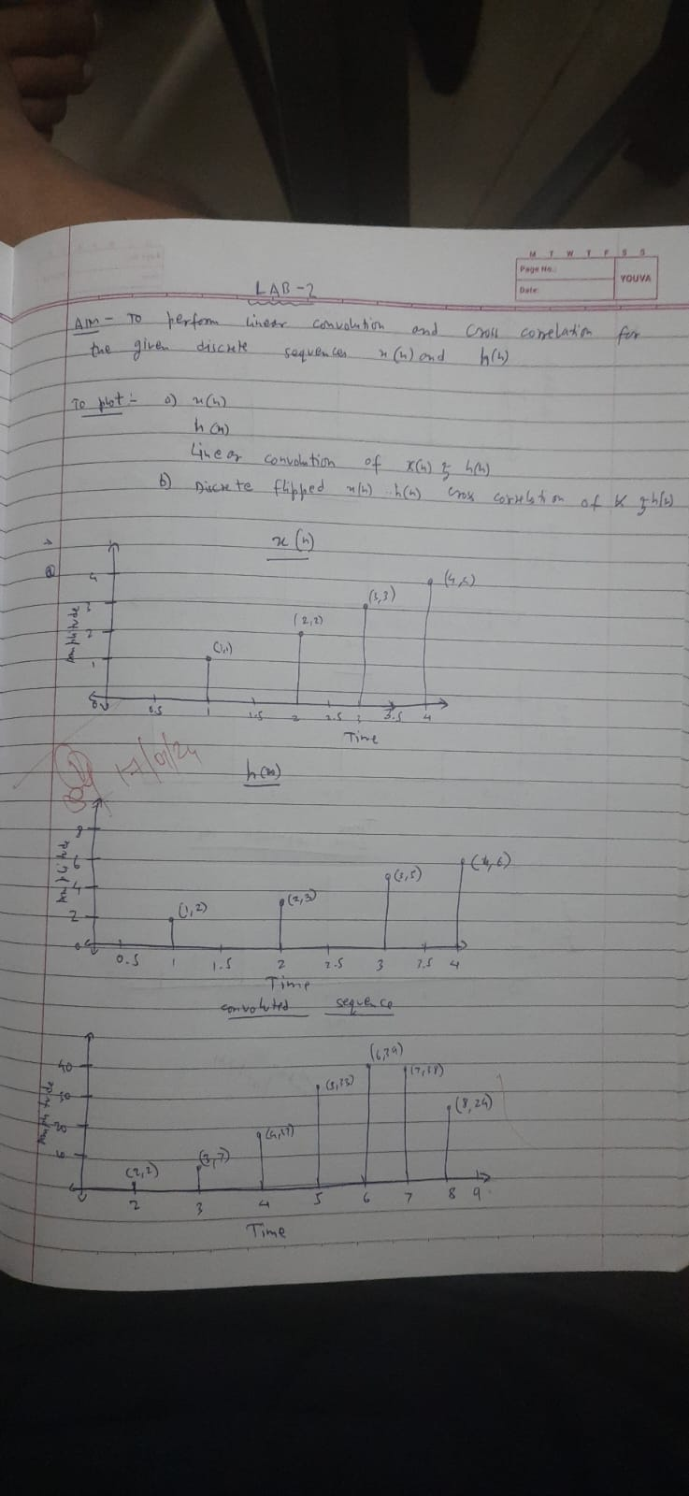

1. **CORRELATION**

